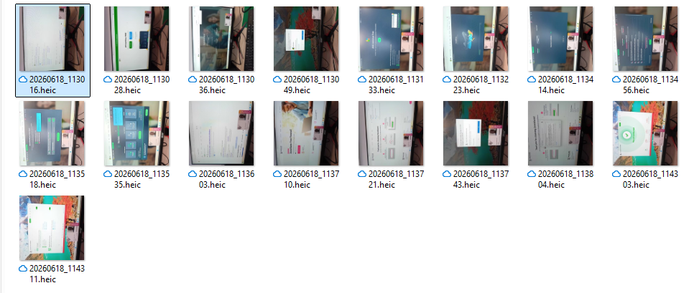
Security Measures to Protect a Technology System

On this unit I installed software utilities on a computer system. I started with antivirus which is called AVG antivirus and I followed the steps to download and keep track on the computer system. To install the firewall was a bit complex. It was called zone alarm firewall but it was basic at the end.

