BTEC Assignment Brief
Qualification | Level 2 First Extended Certificate in Information and Creative Technology
Unit number and title | Unit 10: Database Development
Learning aim(s) (For NQF only) | B: Design a relational database
Assignment title | Designing Database for Local Library
Assessor | Paul Morgan/Aniqa Arooj
Issue date | 26/03/2026
Hand in deadline | 01/05/2026
Vocational Scenario or Context | The Maplewood Town Library want to replace their manual method of recording loans with a new electronic database system to manage their growing collection of books and members. They want to be able to use the system to add new members as well as to record loans. They would also like to be able to search the database for example to find out what loans are still outstanding, which books are currently available for loan etc. Finally, they would like a main menu to enable them to choose different options.  You have been tasked with designing and developing a relational database that will:  You have been tasked with designing and developing a relational database solution that will:  - Store book information (Such as book title, Author, ISBN, Publication Year, Availability Status)  - Maintain member records (such as member name, address, contact number, Join Date)  - Track loan transactions (What book was loaned by which member. The date the book was issued and the expected return date)
Task 1 |  | Design your relational database  You need to create the following design documentation for Maplewood Town Library  - Overview of user requirements  - Table designs for 3 tables to include field names, data types, validation  - Add primary and foreign keys to tables  - An ERD (entity relationship diagram)  - Designs at least two data-entry forms for new members and loans  - Designs for at least 5 queries  - Designs for at least 3 reports.  - Design for at least one main menu form  - Test plan  - Justification for your designs to include alternative ways of creating the database and a review of constraints
Task 2 |  | Develop and test your relational database  Following your designs from task 1 you need to develop a relational database in Access supported by a development report. Your final database and report should include the following:  - Create your database tables  - Import data into your database (50 records across all tables)  - Build relationships between your tables  - Create your data entry forms  - Create your main menu form  - Create your queries  - Create your reports  - Test your database at each stage following your test plan and record results of tests and any changes  - Gather feedback from others on how to improve your final database  - Make refinements to your final database to include  - Validation and error messages in forms  - Onscreen user guidance in forms  - Macros to automate tasks
Task 3 |  | Evaluate and review your relational database  Review your database solution  - Give at least three strengths and one improvement you could make to your database.  - Explain how well your database meets the requirements of the brief?  - Explain any changes you made from your designs and why?  - Provide three recommendations on how you could improve your database?
Checklist of evidence required |  | Task 1 - Design your relational database  Database design documentation (Overview of user requirements, Table designs, ERD Diagram, Form designs, Query designs, Report designs and a Test plan)  Task 2 - Develop and test your relational database  Completed database files/SQL code  Annotated screen shots showing (Table designs and table records; data entry forms; query design and results; reports)  Testing table showing results of tests with screenshots as evidence  Task 3 - Evaluate and review your relational database  A written report evaluating your database
Criteria covered by Task 1 - Design your relational database
Unit/Criteria reference | To achieve the criteria, you must show that you are able to:
2B.P2 | Describe the purpose and user requirements for the database
2B.P3 | Produce a design for a relational database, including a database structure & a test plan.
2B.M2 | Produce a detailed design for a relational database, including alternative designs, a detailed database structure and test data
2B.D2 | Justify final design decisions, explaining how the relational database will fulfil the stated purpose and user requirements, and any constraints in the design.
Criteria covered by Task 2 – Develop and test your relational database
Unit/Criteria reference | To achieve the criteria, you must show that you are able to:
2C.P4 | Develop a relational database with a realistic data set, which includes at least two tables; sorted records and data-entry forms.
2C.P5 | Test the functionality and purpose of the relational database for functionality, repairing any faults.
2C.M3 | Develop the database demonstrating awareness of users’ requirements and accuracy. To include customised dataentry forms; queries and output data reports and onscreen navigation and guidance
2C.M4 | Gather feedback from others and use it to improve the database and test any additional functionality, repairing any faults
2C.D3 | Refine the database solution using automated tools and techniques to improve productivity, accuracy and the presentation of output data, taking account of user feedback
Criteria covered by Task 3 – Evaluate and review your relational database
Unit/Criteria reference | To achieve the criteria, you must show that you are able to:
2D.P6 | Explain how the final database is suitable for the user requirements and purpose.
2D.M5 | Review the extent to which the finished database meets the user requirements, considering feedback from others.
2D.D4 | Evaluate the finished database against the design and justify any changes made, making recommendations for further improvements to the database.

LEARNER ASSESSMENT SUBMISSION AND DECLARATION

When submitting evidence for assessment, each learner must sign a declaration confirming that the work is their own.

Learner name: Nuuh Arale |  |  | Assessor name: Aniqa Arooj
Start date: | Hand in deadline: |  |  | Submitted on: 25/06/26
Qualification: Level 2 First Extended Certificate in Information and Creative Technology
Unit name(s): Unit 10: Databases
Assignment title: Designing Database for Local Library
Please list the evidence submitted for each task. Indicate the page numbers where the evidence can be found or describe the nature of the evidence (e.g. video, illustration).
Task reference |  | Evidence submitted |  | Page numbers or description
Additional comments to the Assessor:

Learner Declaration – I certify that the evidence submitted for this assignment is my own. I have clearly referenced any sources and any artificial intelligence (AI) tools used in the work. I understand that false declaration is a form of malpractice. | Learner signature:  Date:

Assessor Declaration – I certify that to the best of my knowledge the evidence submitted for this assignment is the learner’s own. The learner has clearly referenced any sources and AI tools used in the work. I understand that false declaration is a form of malpractice. | Assessor signature:  Date:

Task 1: Library database introduction
Purpose
Maplewood library wants to keep track of data about books, members, and loans. They have done this manually up until now, however they want to use a computerised system to increase efficiency.
User Requirements
This system will allow users to:
- Insert and update book data
- Insert member data
- Enter loan records
- Search for and filter results
- Run reports
- Navigate using a main menu
Data Dictionary
Books Table:
- Book ID (PK, Number)
- Title (Text)
- Author (Text)
- ISBN (Text)
- Type (Text)
Design of Queries
- Query1: All Books - Displays all books within system.
- Query2: Fiction Books - Filters by fiction books only.
- Query3: Overdue Loans - Displays loans that are overdue.
- Query4: Search Members - Searches member names.
- Query5: Loan Details - Joins tables.
Design of Reports
- List of Books
- Loan Details
- Overdue Loans
Alternative solution
An alternate solution would be to use spreadsheets such as Microsoft Excel. However, a database was a better fit because we can create relationships between tables.
There were some time, skill, and access constraints. Our final design allows users to easily understand how it is designed and navigate using the menu. It fulfils the user requirements.

Task 2: LIBRARY DATABASE

SECTION 1 — TABLES
Books Table
This table holds book data including title, author, year published and type. Each row stores data about one book.
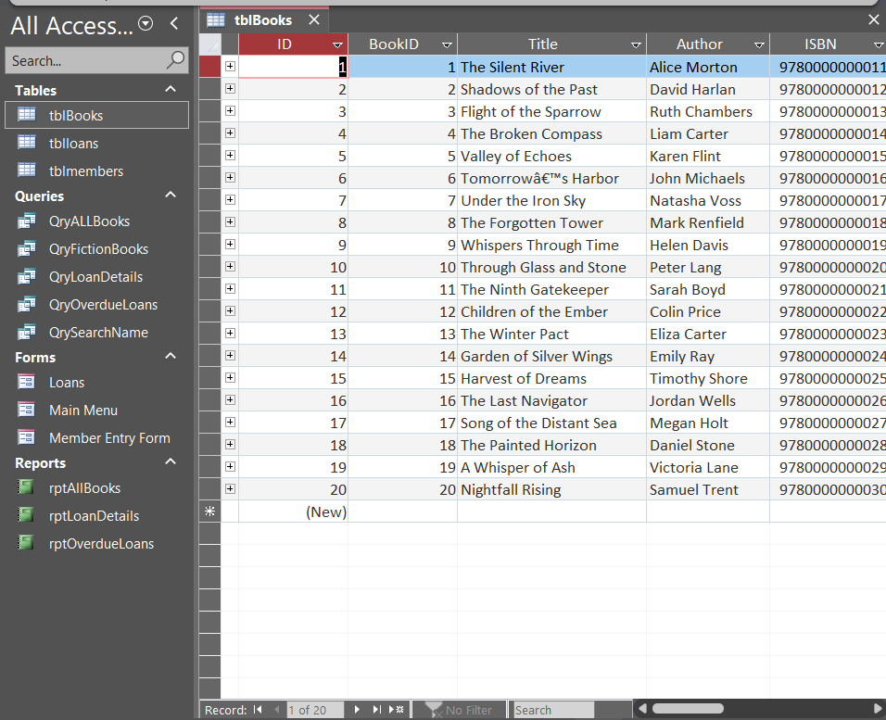

Members Table
This table holds member data including first name, last name, email, and address. Each row stores data about one member.
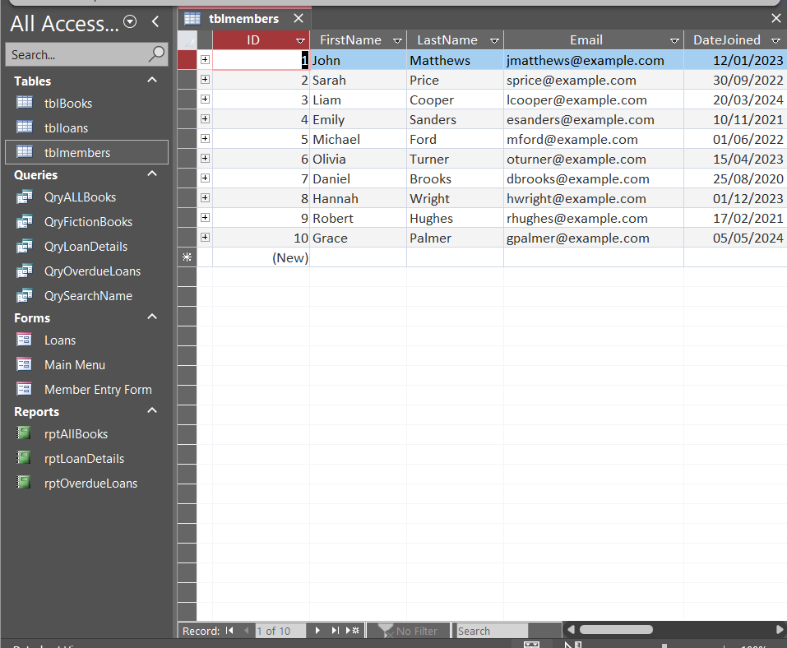

Loans Table
This table holds loan data based on the member and the book on loan. Foreign keys are used from tblBooks and tblMembers. Loan date and due date are also stored.
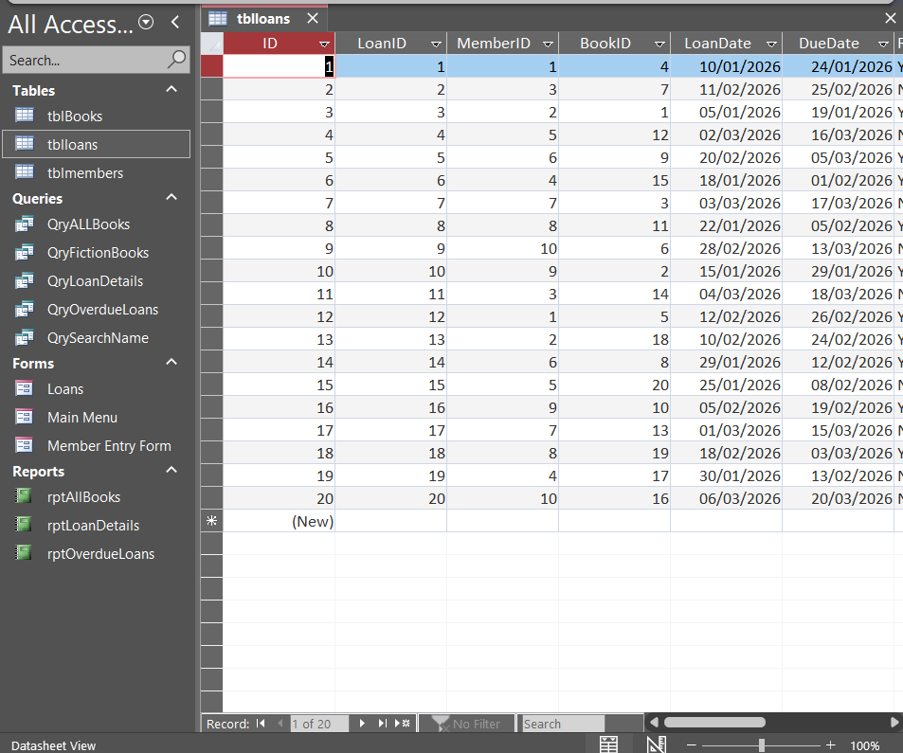

SECTION 2 — RELATIONSHIPS
Database Relationships
This illustrates how the tables relate to each other. The PK’s of tblBooks and tblMembers are used as FK’s in tblLoans. This helps prevent unnecessary duplication and allows for relations between tables.
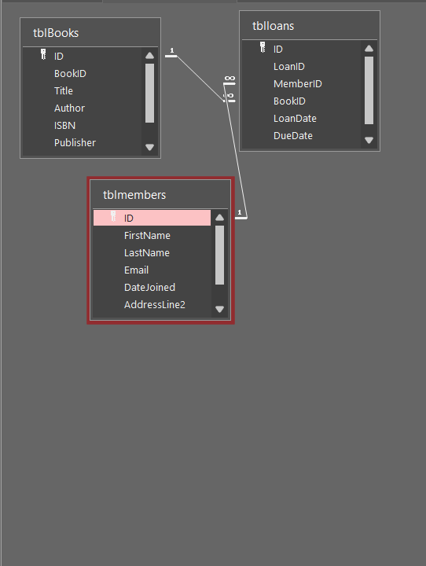

SECTION 3 — QUERIES
All Books Query
This qry allows the user to view all books held in the database.
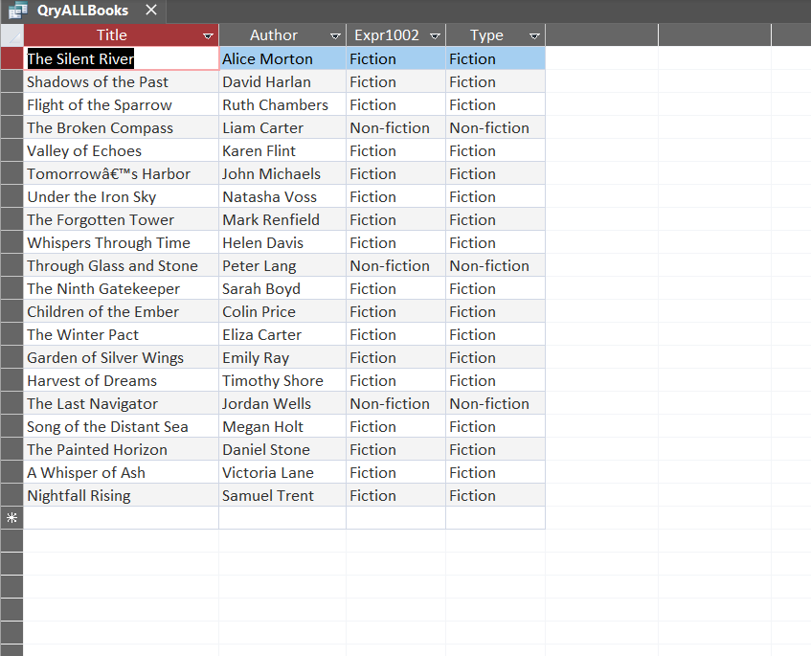
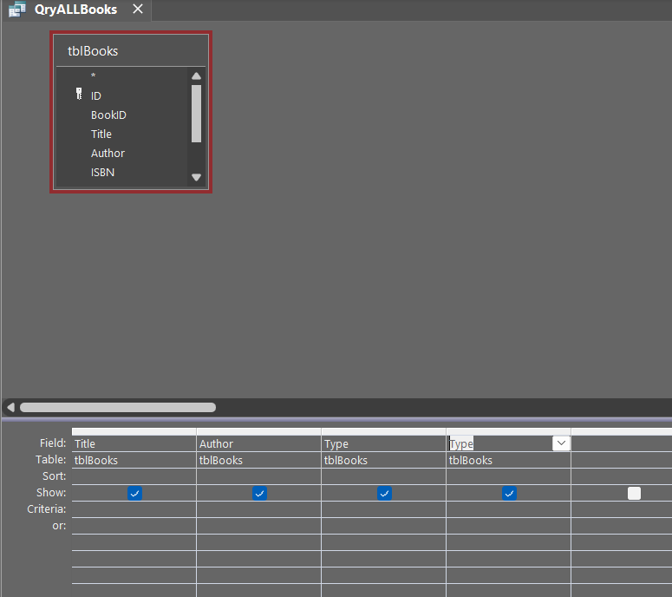

Fiction Books Query
This qry filters the table to show only books of the type “Fiction.” This is the criteria being used.
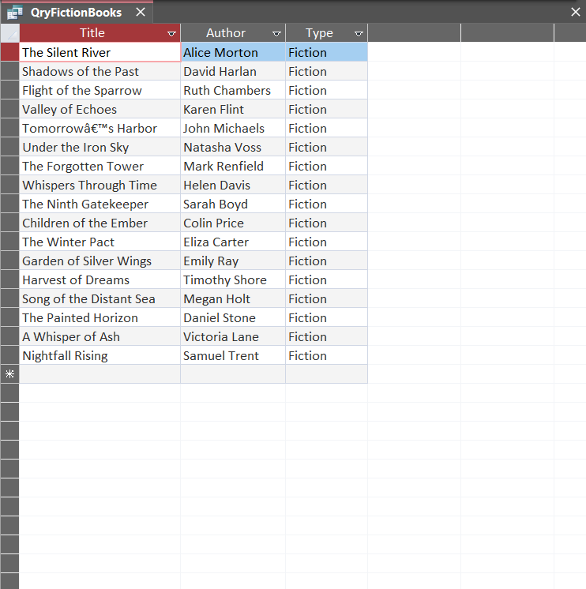
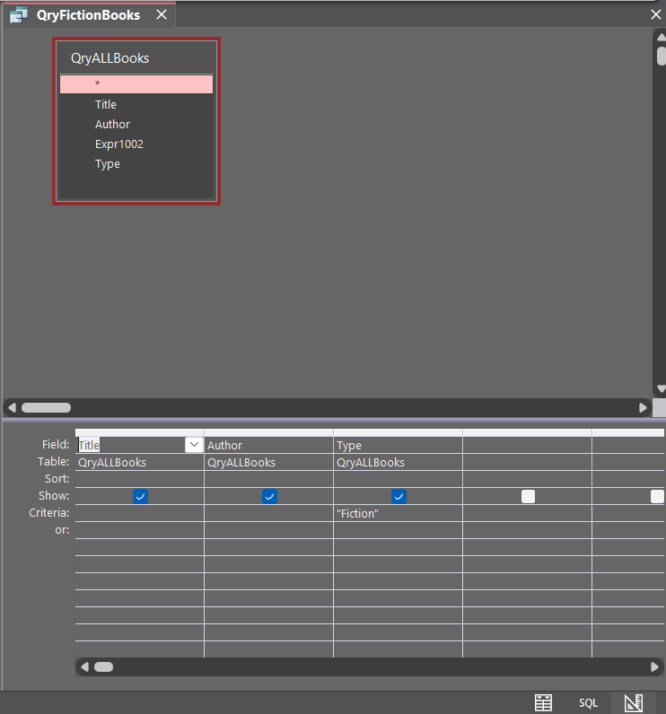

Overdue Loans Query
This qry filters to loans where the book is overdue (Due Date is in the past) and the Return status is “N.” Combines criteria.
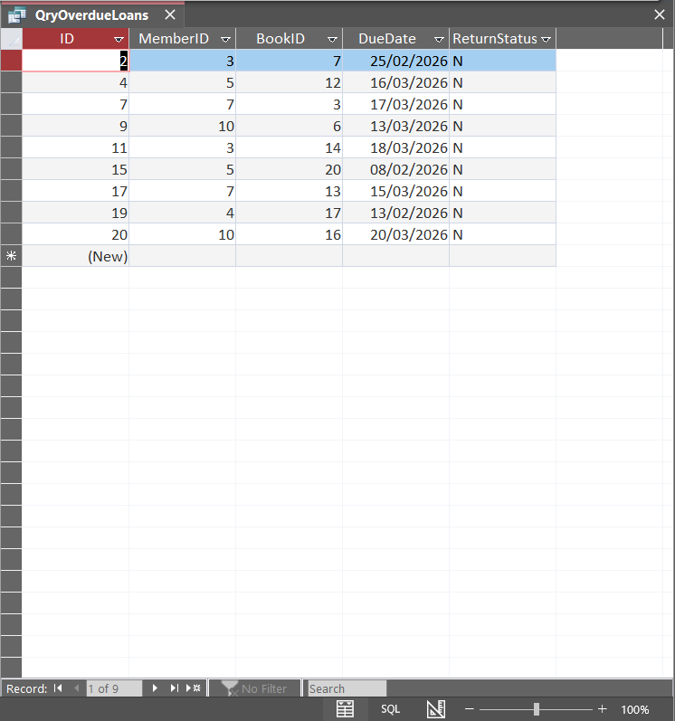
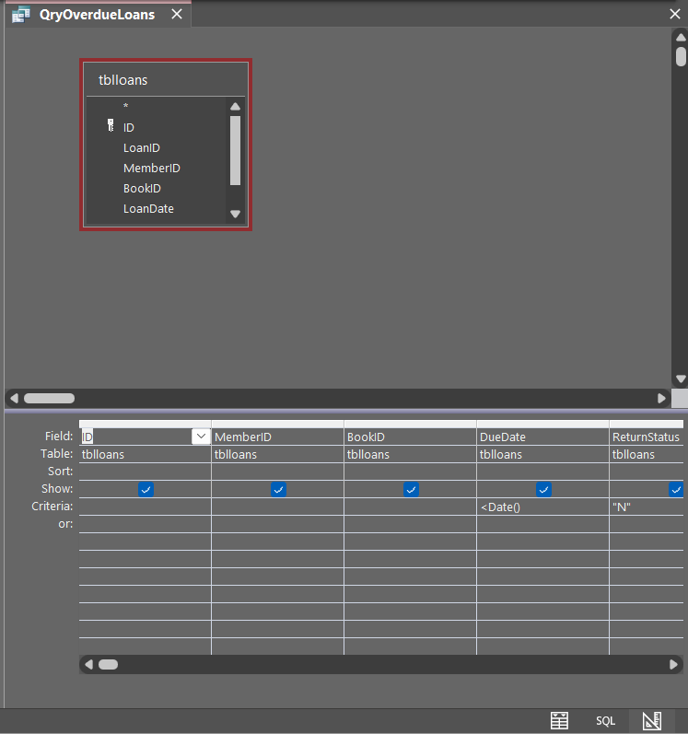

Member Search Query
This qry allows the user to search for parts of characters in members names using a wildcard.

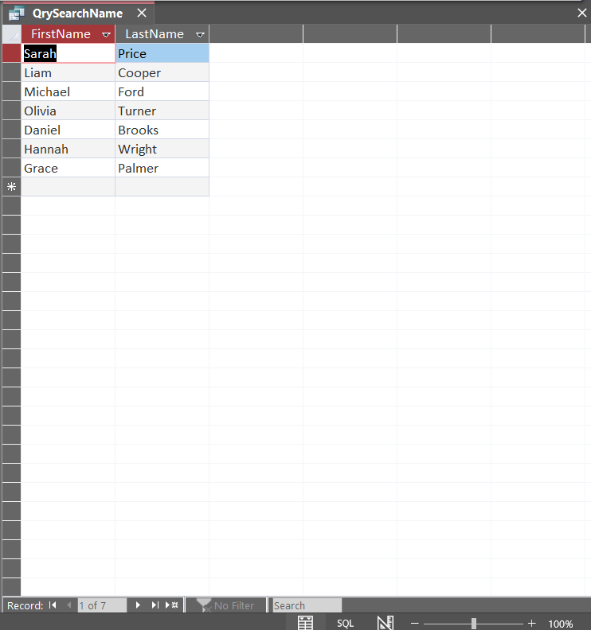
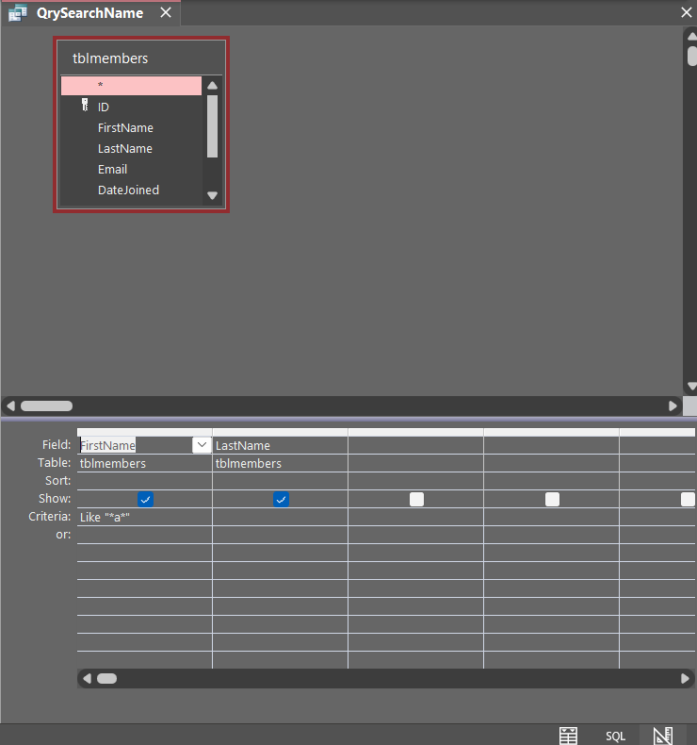

Loan Details Query
This qry combines data from multiple tables to allow members names, books titles and dates borrowed to be displayed.

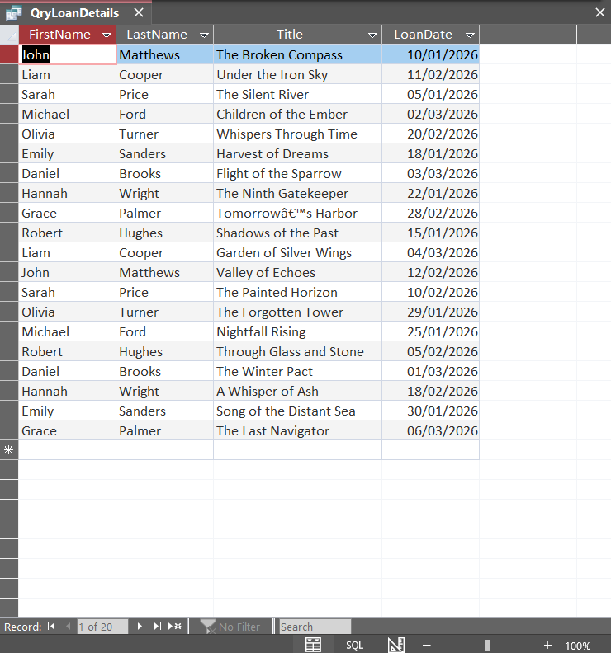
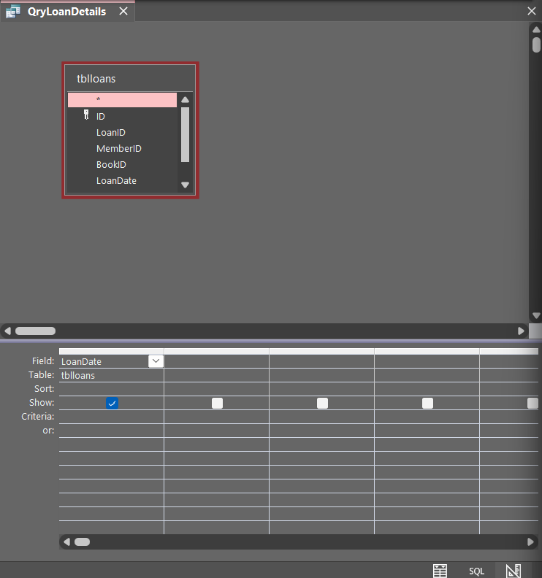

SECTION 4 — FORMS
Member Entry Form
This form has been designed to allow entry and editing of member information. Clearly marked labels and formatted layout will allow for ease of use and minimise data entry errors.

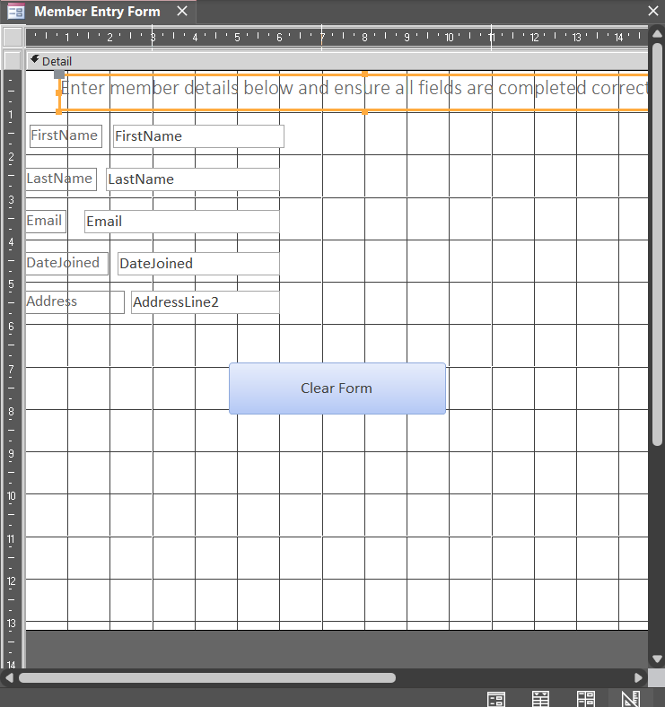

Loan Entry Form
This form has been designed to allow users to record loan information. This will link members to borrowed books.

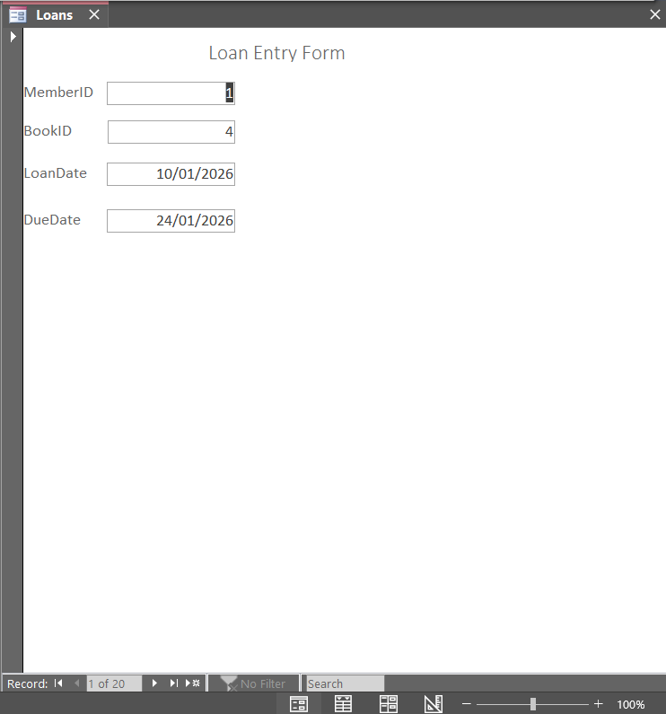
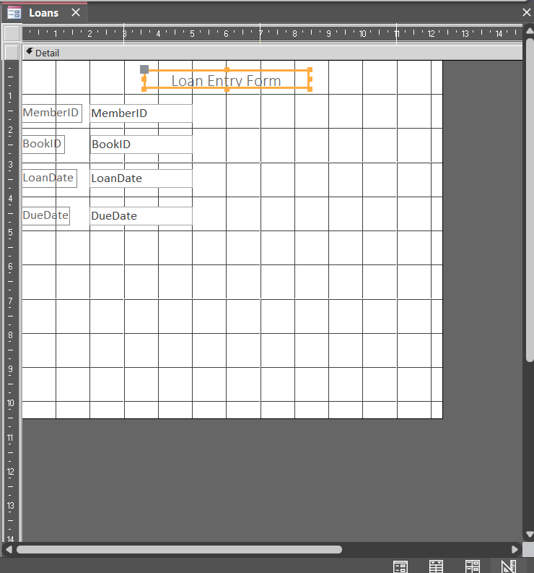

SECTION 5 — REPORTS
Book Report
This report has been designed to display book information. The columns are clearly identified and neatly organised for ease of reading and printing.

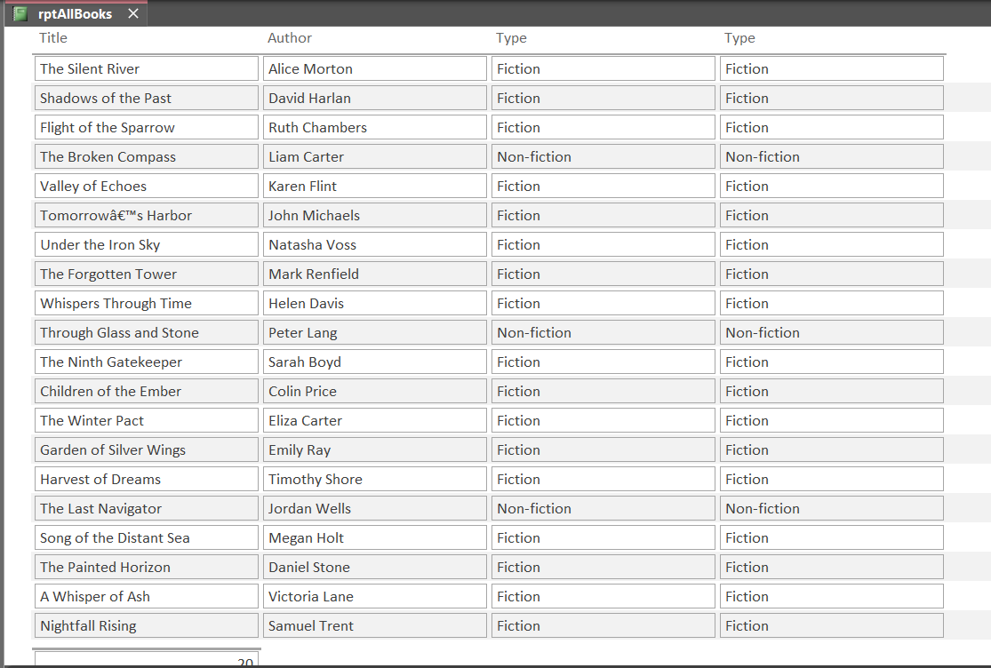
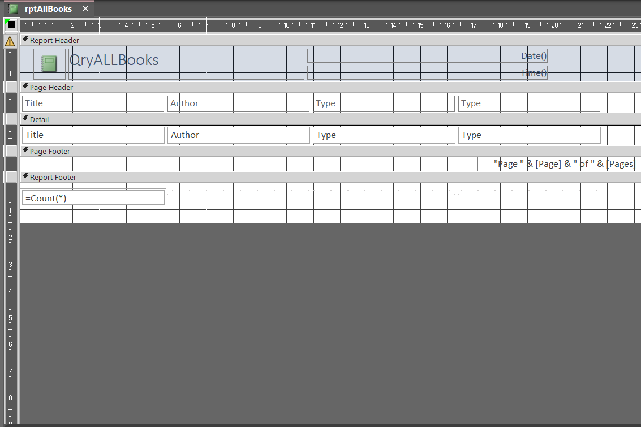

Loan Details Report
This report combines information from multiple tables. This allows staff to view activity over a specified period.
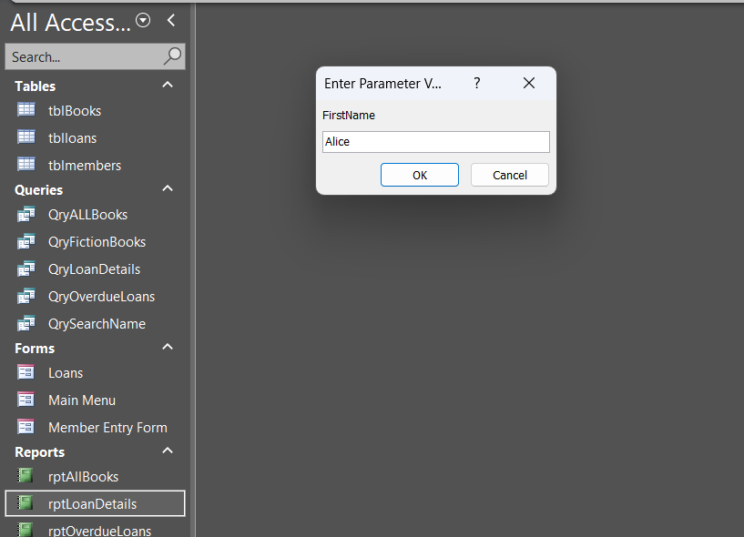
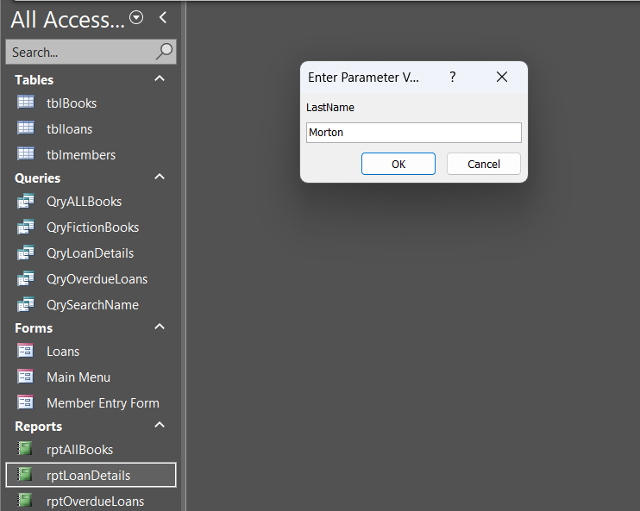
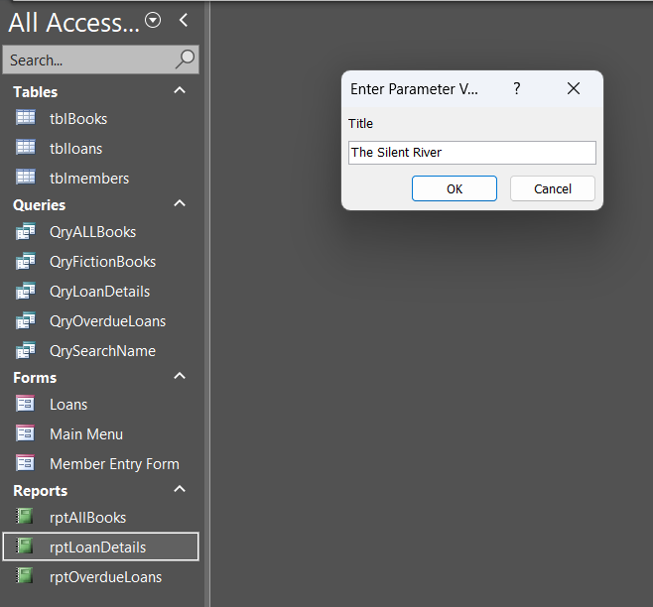
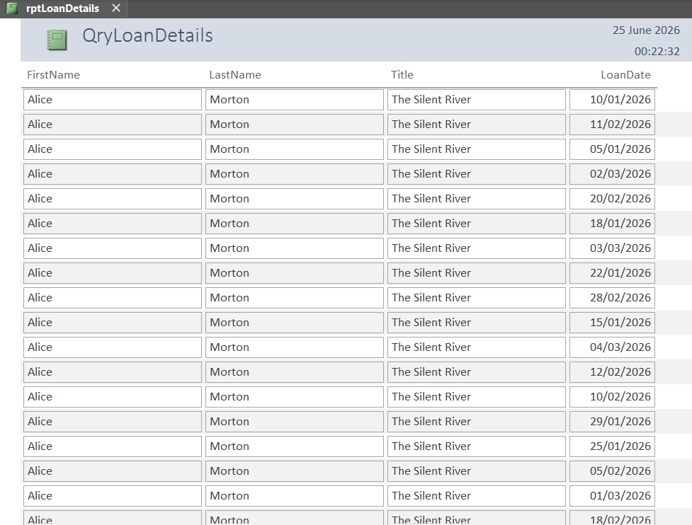
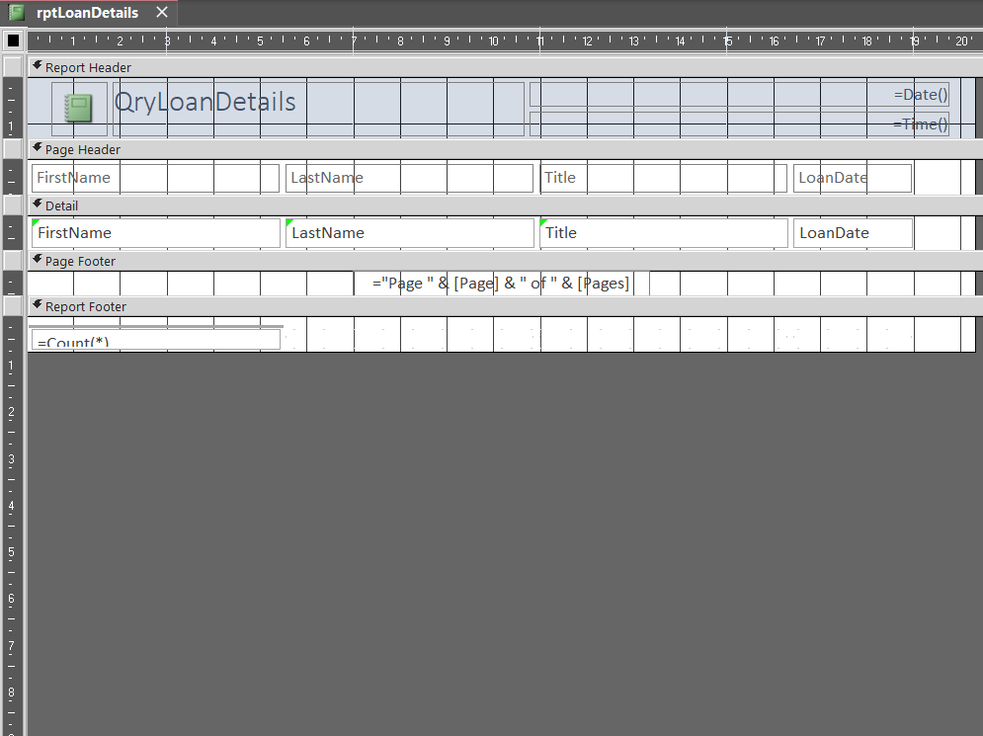

Overdue Loans Report
This report can be used by staff to quickly identify members who have overdue books. Staff can then take appropriate action.
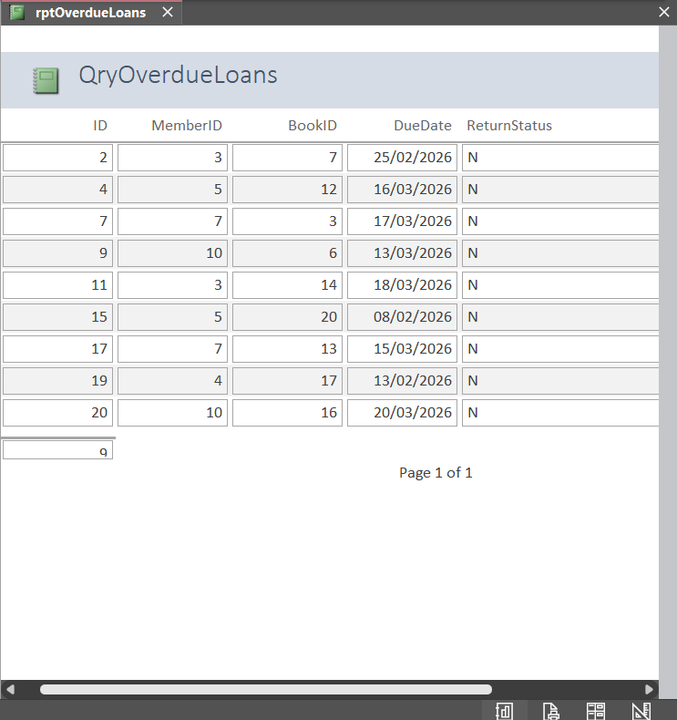

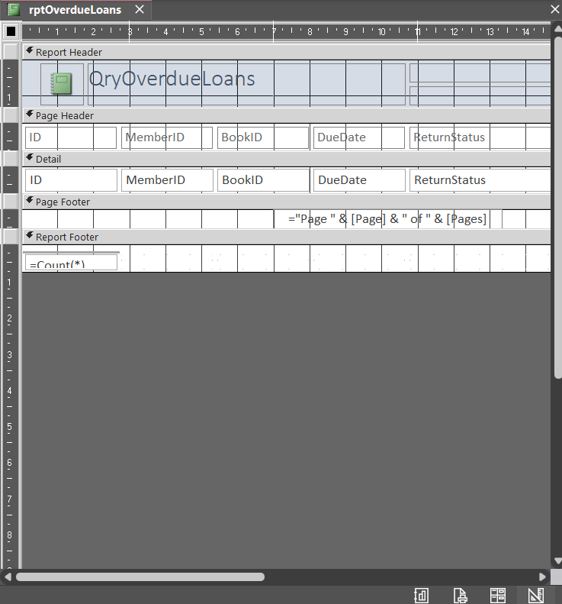

SECTION 6 — MAIN MENU
Main Menu Form
This form has been designed to allow users to navigate through the database. Buttons link to forms and reports allowing for ease of use.

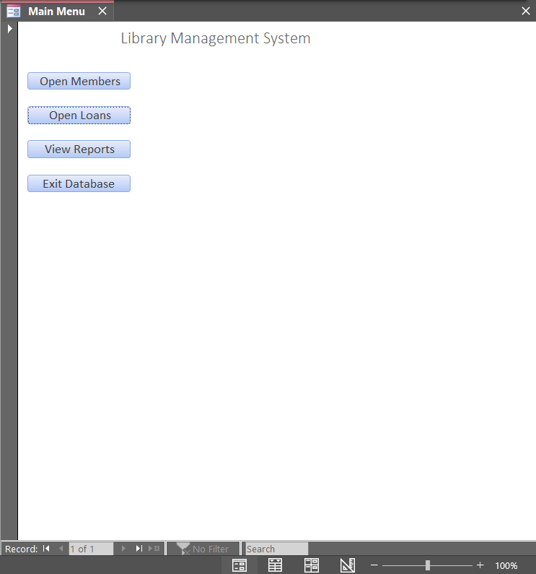

Navigation Button in Use
Screenshot of button opening associated form/report. Useful in proving that buttons work properly and take you to the correct place.

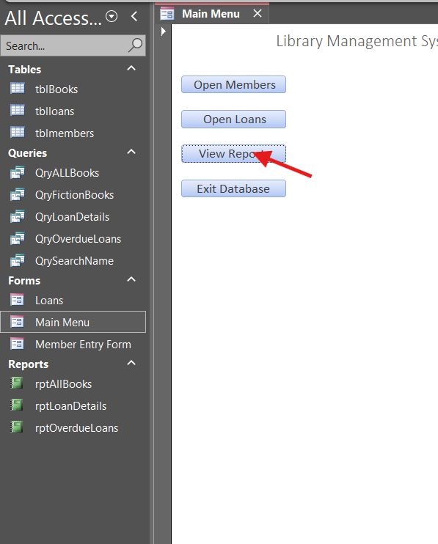
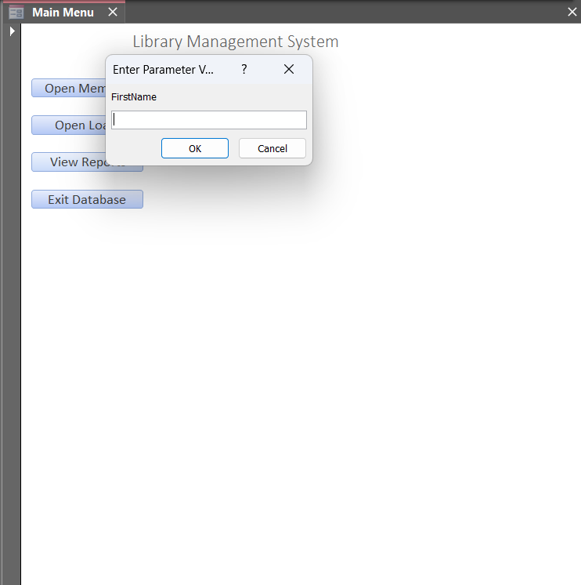

Task 3: Evolution

How it meets requirements:
Database stores book info, member info, and loan transactions. Users can search data and create reports. The database meets the requirements by storing book information, member details and loan transactions. Users can add, edit, and search records using forms and queries. Reports allow staff to clearly view valuable information such as overdue loans, improving efficiency compared to the previous manual system.
Strengths:
Forms/menu make it user friendly. Data is validated and structured, so it will be accurate. Queries allow users to search quickly.
- The system is easy to use due to forms and main menu navigation
- The use of relationships ensures accurate and organised data
- Queries allow fast searching and filtering of information
Weaknesses:
There are few automation functions. Users must know how to use access to edit or update the database.
Improvements:
I calculated overdue fines automatically. More filters can be added to improve search capabilities.
- Add automatic overdue fine calculation
- Improve search with advanced filters
- Add barcode or ID scanning system for books
Changes made:
Some fields should be changed to more suitable types. During development, changes were made such as correcting data types and fixing query errors. These changes improved the accuracy and functionality of the system.

