BTEC Assignment Brief
Qualification |  | BTEC Level 1/Level 2 First Award in Information and Creative Technology  BTEC Level 1/Level 2 First Certificate in Information and Creative Technology  BTEC Level 1/Level 2 First Extended Certificate in Information and Creative Technology  BTEC Level 1/Level 2 First Diploma in Information and Creative Technology
Unit or Component number and title |  | Unit 12: Software Development
Learning aim(s) (For NQF/RQF only) |  | B: Design a software program  C: Develop and test a software program  D: Review the finished software program
Assignment title |  | Currency Exchange Calculator
Assessor |  | Aniqa Arooj
Hand out date |  | 25/11/2025
Hand in deadline |  | 12/12/2025 (If you submit late, your work will be capped at Pass.)
Vocational Scenario or Context |  | You are a programmer working for a software development company. You have been asked to design and develop a program to help a local travel agent calculate currency exchange rates for its customers.  The program should allow the user to enter an amount in British pounds and calculate the equivalent amount in a foreign currency (for example, Euro). The program should also allow for the user to enter an amount in another currency (for example, Euro) and calculate the equivalent in British pounds. The user should be able to alter the exchange rates used to match the current rates.  The amount in the desired currency should be shown along with the current exchange rate between the currencies.
Task 2 |  | Design the Program  As a first step, you need to design the required software solution in line with the local travel agent’s requirements and to meet the required purpose and justify your design discussions.  Produce detailed design documents for the program including the following:  - A description of the user requirements and the intended purpose of the program.  - A problem definition statement that outlines the issues the travel agent is experiencing that could be resolved by your program. You should include:  - the business’s requirements  - the program inputs  - the program outputs  - The relationship between program inputs and outputs is important.  - Screen and user interface designs of your proposed solution – your screen designs should include annotations to show:  - formatting of printed information (e.g., currency)  - restrictions on input/output fields (e.g., text, numerical).  - Screen navigation, simple data structures, data validation and error handling and reporting.  - Identification of which controls need to respond to which events.  - A data dictionary detailing all constants, variables and controls (e.g. text fields) used.  - Pseudo code for events and procedures, or a flow chart showing the processing.  You should also produce:  - a test plan and test data to test for the logic and functionality of the program, e.g. testing the inputs and expected outputs and compilation of the code  - a brief outline of alternative solutions for the intended software program, e.g. for screen layout and navigation  - justification for your chosen designs regarding the user requirements and identification of any constraints  You should also explain why alternative designs ideas were rejected.
Checklist of evidence required |  | Design documentation that includes:  - user requirements and purpose of the program  - problem definition  - storyboard or images of screen designs (input and output) with data validation and error handling and reporting  - functions/subroutines  - flow chart showing the processing  - test plan and data  - alternative solutions  justification for the design.
Criteria covered by this task:
Unit/Criteria reference | To achieve the criteria, you must show that you are able to:
12/2B. P2 | Describe the purpose and user requirements for the software program.
12/2B. P3 | Produce a design for a program, including:  - a problem definition statement  - a proposed solution  - a list of any pre-defined functions/subroutines  a test plan.
12/2B.M2 | Produce a detailed design for a program, including:  - alternative solutions  - a detailed proposed solution using a range of design tools  test data.
12/2B. D2 | Justify the design decisions, including:  - how they will fulfil the stated purpose and user requirements  any design constraints.

Task 3 |  | Develop and Test the Program  It is time to develop and test your software solution for the local travel agent and refine the software program, considering the code's quality and user feedback.  - Create the user interface with both inputs and outputs.  - Implement the code for the program, including annotations within the code showing where and why constructs or techniques have been used (e.g., local variables, sequence, assignment).  - Test the functionality of the software solution against the test plan and, using the test data, ensure that the program meets the original requirements of the travel agent.  Remember to keep evidence of any changes made to the code and record any repairs that you make by adding comments about any issues and notes about how they were resolved. Changes to the program should be documented. Different versions from stages of development could be used to evidence this.  Arrange a meeting with your tutor to demonstrate your software solution. You should discuss the functionality and usability of the programme and record this feedback as part of the testing process. Use the discussion to review your designs, quality of the code (for example, maintainability, portability, and usability) and to improve the program.  All the ideas from the testing, user feedback and reviewing the software program should be considered when refining the product.
Checklist of evidence required |  | - Original program code with annotations.  - Annotated refined code for the program (after testing).  - Testing table and data.  - Program review.  - Feedback from others.  - Witness statement.
Criteria covered by this task:
Unit/Criteria reference | To achieve the criteria, you must show that you are able to:
12/2C. P4 | Develop a program for a given brief, which includes:  - a user interface (input and output)  - constructs/techniques  commentary throughout the code.
12/2C. P5 | Test the program for the functionality using the test plan and against the original requirements and repair any faults.
12/2C.M3 | Develop a functional program that meets the given brief.
12/2C.M4 | Test the program using the test data, gathering feedback from others on the usability and quality of the program, and use it to improve the software program. Repair any faults.
12/2C. D3 | Refine the software program, taking account of the quality of the code and user feedback.

Task 4 | The Review  It is now time to complete a review and evaluate the results of the testing and how well the program fits its intended purpose and meets the original requirements.  - Review the extent to which the software program is fit for purpose and meets the original requirements.  - Evaluate the initial designs against the completed program.  - Consider changes you would like to make in the light of user feedback.  - Identify any changes made from the design stage and justify these changes in terms of the original requirements and the features of the language used, and any other constraints.  - Make at least three recommendations for how you can further improve the completed program to ensure it is fully functional, well coded and fit for purpose.  You do not need to implement the recommendations.

Checklist of evidence required |  | Evaluation report.
Criteria covered by this task:
Unit/Criteria reference | To achieve the criteria, you must show that you are able to:
12/2D. P6 | For the software program, explain how the final software program is suitable for the original requirements and purpose.
12/2D.M5 | Review the extent to which the software program meets the original requirements, considering feedback from others and any constraints.
12/2D. D4 | Evaluate the final software programs against the initial  designs and the quality of the code, and justify any changes made, making recommendations for further improvement.

Sources of information to support you with this Assignment | Books  Foxall, J. (2010) Sams Teach Yourself Visual Basic 2010 in 24 Hours: Complete Starter Kit, Sams, 978 0 67233 113 8  Halvorson, M. (2010) Microsoft® Visual Basic® 2010 Step by Step, Microsoft Press, 978 0 73562 669 0  Stephens, R. (2010) Visual Basic 2010 Programmer's Reference (Wrox Programmer to Programmer, John Wiley & Sons, 978 0 47049 983 2  Willis, T., and Newsome, B. (2010) Beginning Visual Basic 2010 (Wrox Programmer to Programmer, John Wiley & Sons, 978 0 47050 222 8
FOR 2012 L1/2 FIRSTS ONLY: If you have not achieved the Level 2 criteria, your work will be assessed to determine if the following Level 1 criteria have been met.

Criteria covered by this task:
Unit/Criteria reference | To achieve the criteria, you must show that you are able to:
12/1A.1 | Identify the purpose of two simple programs and their characteristics, including tools and techniques used.
12/1B.2 | Identify the purpose and user requirements for the software program.
12/1B.3 | Produce, with guidance, a design for a program, including:  - a problem definition statement  an outline of the proposed solution.
12/1C.4 | With guidance, develop a program for a given brief, that contains:  - a user interface (input and output)  constructs/techniques.
12/1C.5 | With guidance, test the program for functionality and against the original requirements and repair any faults.
12/1D.6 | For the software program, identify how the final program is suitable for purpose and the original requirements.

LEARNER ASSESSMENT SUBMISSION AND DECLARATION

When submitting evidence for assessment, each learner must sign a declaration confirming that the work is their own.

Learner name: Nuuh Arale |  |  | Assessor name: Aniqa Arooj
Start date: 24 November 2025 | Hand in deadline: 12 December 2025 |  |  | Submitted on: 01/05/2025
Qualification: Pearson BTEC Level 2 National Foundation Diploma in Information Technology
Unit name(s): Unit 12: Software development
Assignment title: Software development
Please list the evidence submitted for each task. Indicate the page numbers where the evidence can be found or describe the nature of the evidence (e.g., video, illustration).
Task reference |  | Evidence submitted |  | Page numbers or description
Task1 |  | Yes |  | PPT
Task 2
Task 3
Task 4
Additional comments to the Assessor

Learner Declaration – I certify that the evidence submitted for this assignment is my own. I have clearly referenced any sources and any artificial intelligence (AI) tools used in the work. I understand that false declaration is a form of malpractice. | Learner signature: NA Wonder  Date: 28/11/2025

Assessor Declaration – I certify that to the best of my knowledge the evidence submitted for this assignment is the learner’s own. The learner has clearly referenced any sources and AI tools used in the work. I understand that false declaration is a form of malpractice. | Assessor signature:  Aniqa Arooj  Date:

Task 2

Introduction

1. Purpose and User Needs:
This app helps a travel agent quickly convert GBP to other currencies (USD, EUR, AUD, JPY). It shows the current rate, lets users update rates easily, and keeps things simple to avoid mistakes during busy times.
Select from/to currencies
Enter amount to convert
See conversion result and rate used
Update rates manually
Clear fields
Exit app
Get error alerts for bad inputs

2. Problem Definition:

Right now, agents do conversions by hand or switch between websites. This causes errors, uses old rates, and slows down service.
Business needs: Accurate conversions for main currencies, up-to-date rates, fast and easy use.
Inputs: Amount (number), from currency, to currency.
Outputs: Converted amount, shown rate, error messages.
How it works: Result = amount × rate (rates stored and updated).

Task 3

- Aim
Build an easy-to-use program that converts any amount from one foreign currency to another.

- Why GUI (Tkinter)?
- Dropdowns stop wrong currency codes
- Click button → instant result
- Much better than typing everything in console

- Main Parts of My Program
- Dictionary of exchange rates (USD = 1.00, others compared to USD)
- Amount box + two dropdowns (From / To)
- Convert button
- Result box to show answer

- How Conversion Works amount
- _in_USD = amount ÷ rate_of_from_currency final_amount = amount_in_USD × rate_of_to_currency (Works for any pair of currencies)

- Steps I Took
- Made simple console version first (to test maths)
- Built window with labels and boxes
- Added dropdowns and button
- Fixed grid/pack error so it runs
- Added checks (no empty or negative amounts)

- Why My Design is Good
- User can’t pick wrong currency (dropdown only)
- Clear labels and big result area
- No crashing because of error messages

Test plan
Test No | Purpose | Test Data / Action | Expected Outcome
1 | Normal conversion | 100 GBP → EUR | Correct amount in EUR + rate shown
2 | Reverse conversion | 100 EUR → GBP | Correct amount in GBP + rate shown
3 | Same currency | 50 GBP → GBP | Shows 50.00 GBP = 50.00 GBP
4 | Invalid – letters in amount | Type “ABC” → Convert | Error message “Please enter a positive number”
5 | Invalid – negative amount | -25 → Convert | Error message “Please enter a positive number”
6 | Large amount | 999999 GBP → JPY | Correct big number, no crash
7 | Change rate & test again | Change EUR rate to 1.30 → 100 GBP → EUR | Uses new rate (130.00 EUR) and shows updated rate

Flow chart

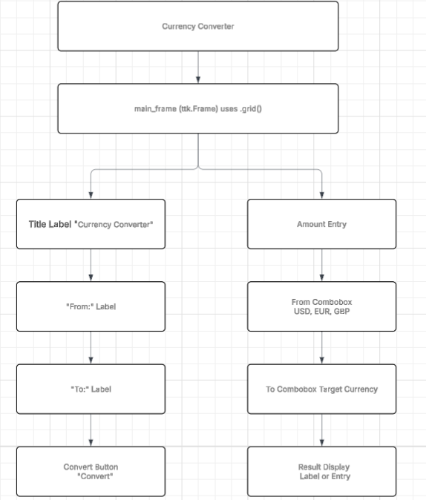

The Interface code

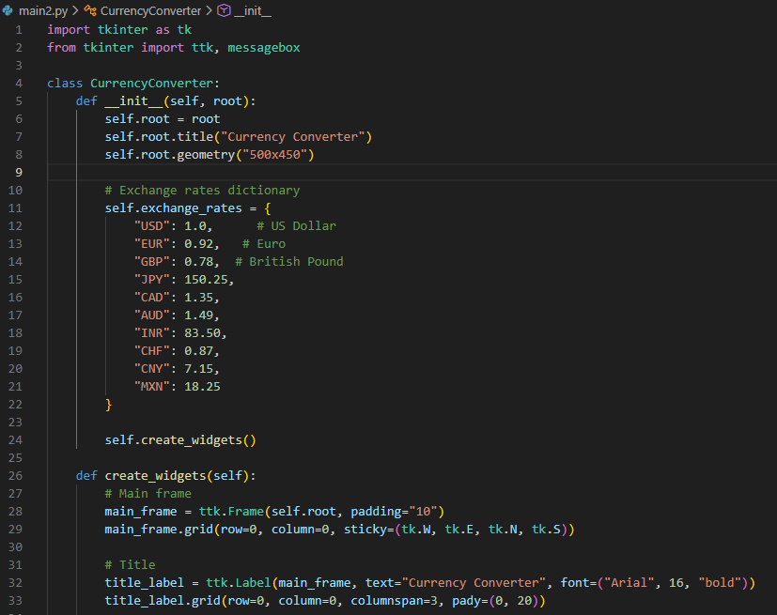

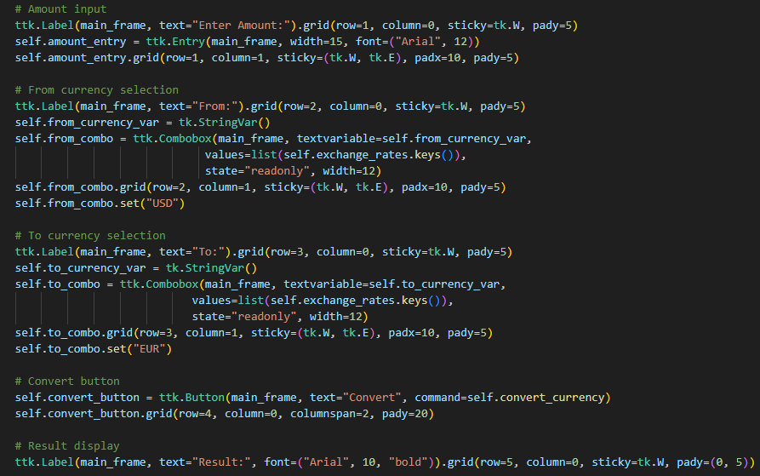

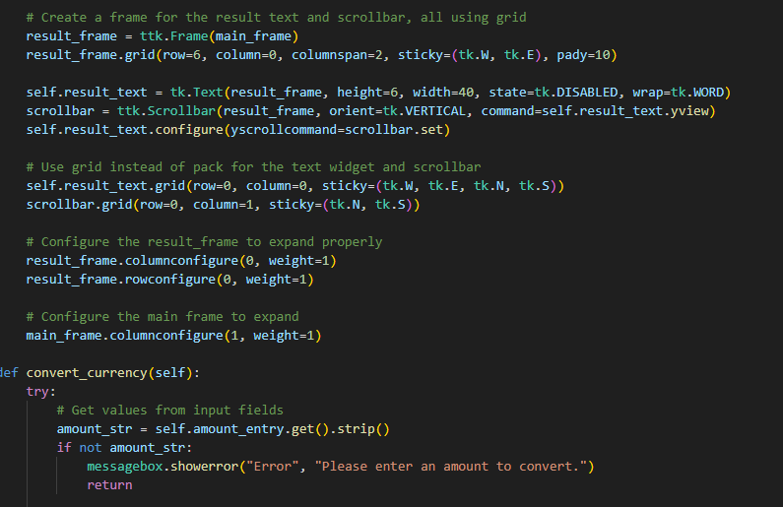

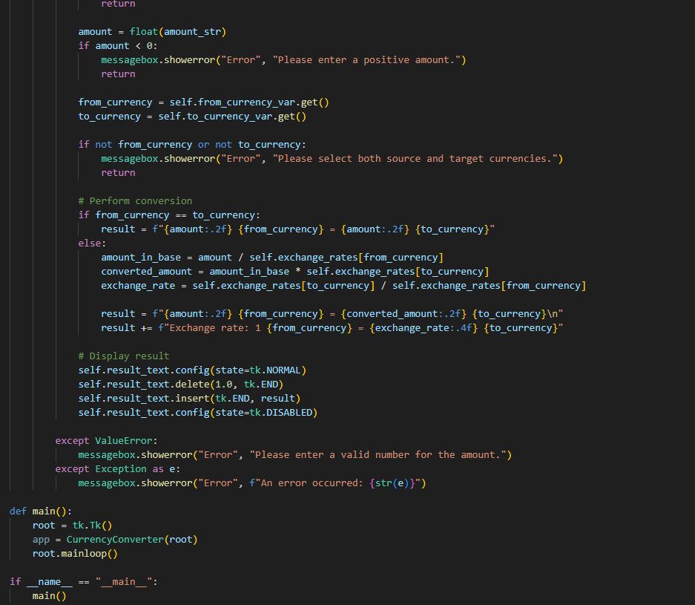

The interface results

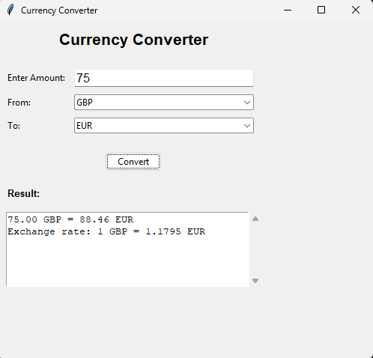
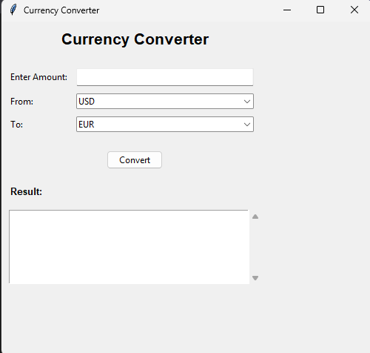

Task 4 – Review

How well the program meets the requirements
The final currency‑converter program meets all the main requirements from the brief. It allows the user to choose a “from” and “to” currency, enter an amount, and get a correct converted value. It also shows the exchange rate used. During testing, all normal, large and invalid inputs behaved as expected, and the program did not crash. The validation system stops letters, symbols and negative numbers, which makes the program reliable for a travel agent to use.
Review of the design vs the final program
Most of the original design ideas were used, such as dropdown menus, a dictionary of exchange rates, and a simple interface with input → convert → output. One change made was adding more currencies (USD, AUD, JPY) instead of only GBP ↔ EUR, because this makes the program more useful in real situations. Another change was improving validation after early tests showed that the program crashed with incorrect input. The layout was also spaced out more after feedback to make it clearer.

Feedback and constraints
User feedback showed that the interface needed to be clearer and that mistakes should not cause errors. These were improved in the final version. Constraints included using Tkinter (which has simple styling), limited time, and not being able to use an online API, so rates must be updated manually.

